Project report
My project’s name is PirateGame. It’s a game. In this game, you could operate a person by your keyboard, and you should push the three boxes to those islands respectively.
The following is my main window:
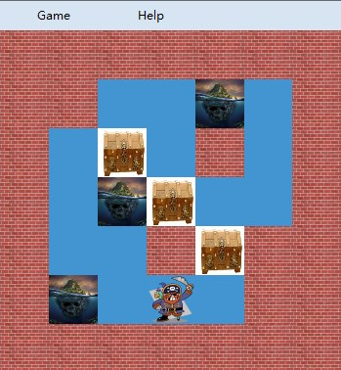
person
box1
box2
island3

box3
wall2

island2
wall3
island1
wall1

wall4

wall5

The top is a menu. It includes restart, exit and an introduction of this game.
Then, it’s my game surface. There is a panel, and in this panel, there are a person (PictureBox) who can move by your keyboard, three boxes (PictureBox) which can be pushed, three islands (PictureBox) which are the goal of the boxes, and many walls (PictureBox) which can’t be passed.
The panel’s size is 250*250, and every PictureBox is 50*50.
In my code, there are two main functions, Action and Judge.
- Action
private void Form1_KeyDown(object sender, KeyEventArgs e)
{
Action action = new Action(person, box1, box2, box3, island1, island2, island3,
wall1, wall2, wall3, wall4, wall5, panelMap);
switch (e.KeyCode)
{
case Keys.Up:
action.push_up();
this.person.Location = action.person.Location;
this.box1.Location = action.box1.Location;
this.box2.Location = action.box2.Location;
this.box3.Location = action.box3.Location;
break;
case Keys.Down:
action.push_down();
this.person.Location = action.person.Location;
this.box1.Location = action.box1.Location;
this.box2.Location = action.box2.Location;
this.box3.Location = action.box3.Location;
break;
case Keys.Left:
action.push_left();
this.person.Location = action.person.Location;
this.box1.Location = action.box1.Location;
this.box2.Location = action.box2.Location;
this.box3.Location = action.box3.Location;
break;
case Keys.Right:
action.push_right();
this.person.Location = action.person.Location;
this.box1.Location = action.box1.Location;
this.box2.Location = action.box2.Location;
this.box3.Location = action.box3.Location;
break;
}
}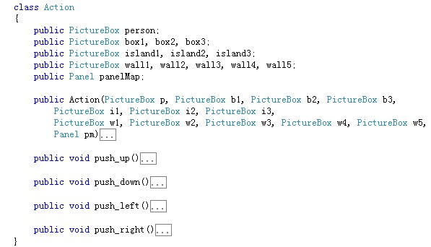

First, when you click down a keyboard, you will new an object Action (action). And put the PictureBox objects which in the panel (panelMap) and the panel into the object Action. Then, according to the key which you click, it will call action.push_up(), action.push_down(), action.push_left() or action.push_right() method. And it calculates location of every PictureBox, then lets current locations of PictureBox equals them.
Because these four methods are very similar, I’ll detail just one of them. For example the method push_right(). When you click down key Right, it’ll call action.push_right().
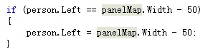
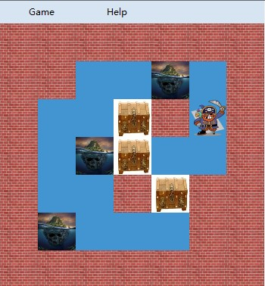

When person meets the right edge of the panelMap, you can’t pass it.
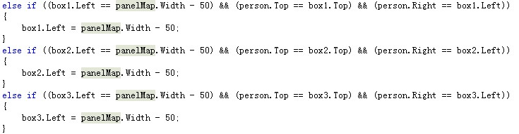
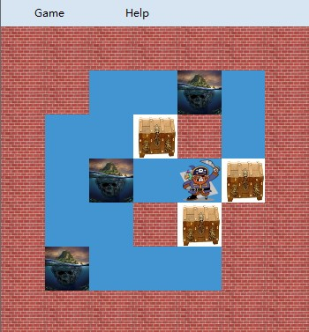

When a box meets the right edge of the panelMap, the person can’t push the box to pass the edge.
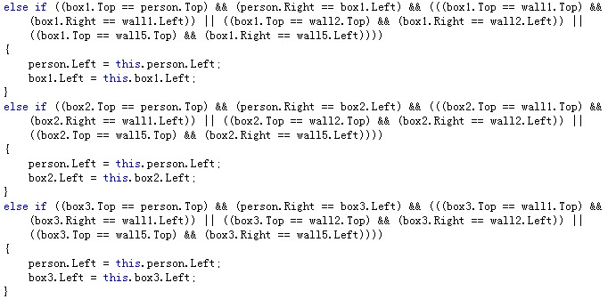

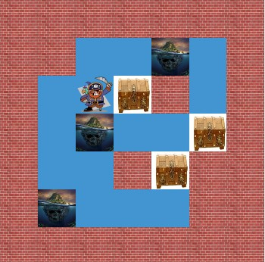

When the person push a box and meets a wall in the panelMap, the person can’t push the box to pass the wall.

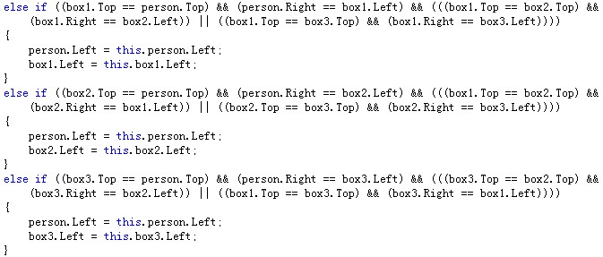
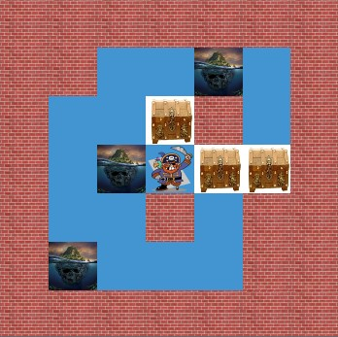

When the person push a box and meets another box, they can’t push the box to pass another box.
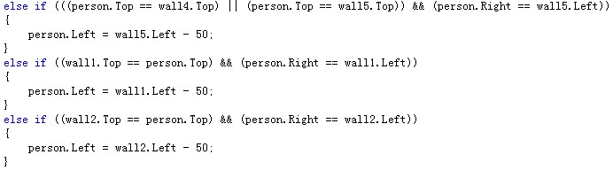
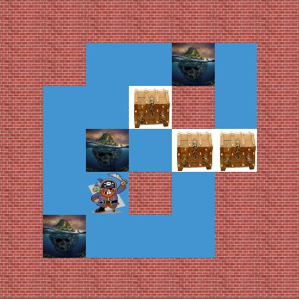

When the person meets a wall in the panelMap, the person can’t pass the wall.
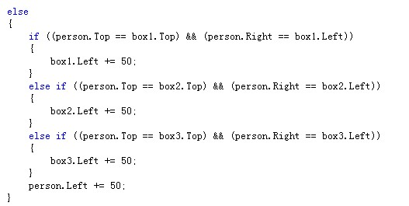
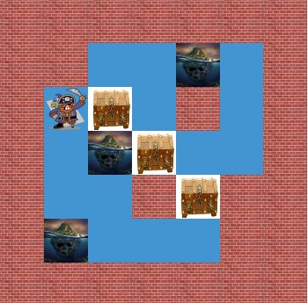

When there isn’t object front of the person, then, the person move 50. When there isn’t object front of the box, then, then person and the box which is pushed move 50.

- Judge
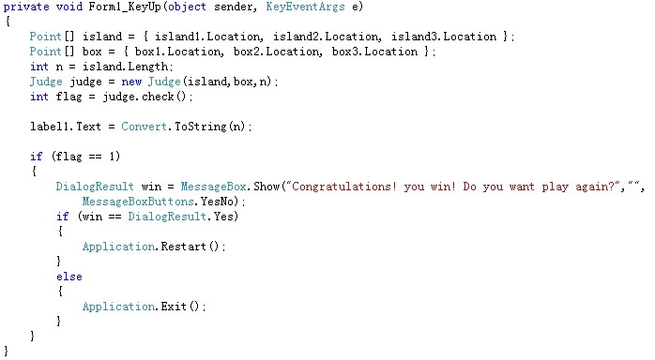

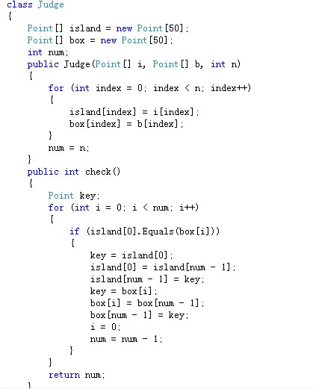

When you click up your key, it will check it and judge if you have wined.
First it put the locations of boxes and islands into two arrays. Then, it new an object Judge, and send the two arrays to the object Judge. And then, it call the method judge.check(). It’ll check if the first location of islands and boxes are equal. If they are equal, make them change with the last element of their arrays; and ignore the last element of their arrays, and go on checking the first element of their arrays. Else, check if the first element of island and the next element of box are equal. At last it returns the scale of not equal.
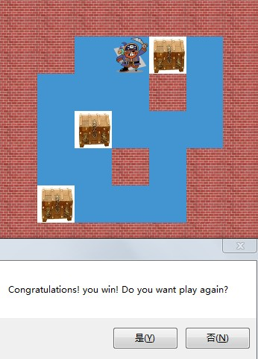
Yes
No
If all of them are equal, you win.

